***2014*** 7212

1 of 6

Students

**SUBJECT: RESPONSE TO INTERVENTION (RTI) PROCESS**

Response to Intervention (RtI) is a multi-tiered early prevention and intervention system designed to improve outcomes for all students. In accordance with Commissioner's Regulations, the School District has established administrative practices and procedures for implementing District-wide initiatives that address a Response to Intervention (RtI) process applicable to all students. For students suspected of having a potential learning disability, the District will provide appropriate RtI services pursuant to Commissioner's Regulations prior to a referral to the Committee on Special Education (CSE) for evaluation.

The New York State Education Department (SED) has released a guidance document to assist school districts in designing and implementing an effective RtI process. This document includes, but is not limited to, information regarding regulatory requirements, quality indicators, staff development, tools to assist districts in selecting a specific model and procedures for the use of RtI data in determining if a student has a learning disability. This guidance document is available at:

http://www.p12.nysed.gov/specialed/RTI/guidance/cover.htm.

The Base School District has established procedures for identifying students with learning disabilities that use a research-based RtI process prior to, or as part of, an individual evaluation to determine whether a student has a learning disability. An RtI process is **required** for all students in grades kindergarten through grade 4 suspected of having a learning disability in the area of reading. RtI cannot be utilized as a strategy to delay or deny a timely initial evaluation of a student suspected of having a disability under the Individuals with Disabilities Education Act (IDEA).

**Minimum Requirements of District's R**t**I Program**

The District's RtI process shall include the following minimum requirements:

a) Scientific, research-based instruction in reading and mathematics provided to all students in the general education class by qualified personnel. Instruction in reading, per Commissioner's Regulations, shall mean scientific, research-based reading programs that include explicit and systematic instruction in phonemic awareness, phonics, vocabulary development, reading fluency (including oral reading skills) and reading comprehension strategies;

(Continued)

***2014*** 7212

2 of 6

Students

**SUBJECT: RESPONSE TO INTERVENTION (RTI) PROCESS (Cont'd.)**

b) Screenings shall be provided to all students in the class to identify those students who are not making academic progress at expected rates;

Students in grades K-8 will participate in AIMSweb universal screenings in reading and math three times a year.

c) Scientific, research-based instruction matched to student need with increasingly intensive levels of targeted interventions for those students who do not make satisfactory progress in their levels of performance and/or in their rate of learning to meet age or grade level standards;

d) Repeated assessments of student achievement which should include curriculum based measures to determine if interventions are resulting in student progress toward age or grade level standards;

e) The application of information about the student's response to intervention to make educational decisions about changes in goals [i.e., goals for all students, not just Individualized Education Program (IEP) goals], instruction and/or services and the decision to make a referral for special education programs and/or services; and

Student progress will be reviewed at least quarterly by classroom teachers, reading specialists, special education teachers, the school psychologist, and building principals.

f) Written notification to the parents when the student requires an intervention beyond that provided to all students in the general education classroom that provides information about:

1. The amount and nature of student performance data that will be collected and the general education services that will be provided as enumerated in Commissioner's Regulations;

2. Strategies for increasing the student's rate of learning; and

3. The parents' right to request an evaluation for special education programs and/or services.

*\* and **District must customize*

(Continued)

***2014*** 7212

3 of 6

Students

**SUBJECT: RESPONSE TO INTERVENTION (RTI) PROCESS (Cont'd.)**

**Structure of Response to Intervention Program**

Fillmore Central School will implement a three tier response to intervention program as outlined in the approved Fillmore Central School Response to Intervention Service Plan.

RtI *minimally* includes:

* **Appropriate instruction** delivered to all students in the general education class by qualified personnel.
* **Screenings** applied to all students in the class to identify those students who are not making academic progress at expected rates.
* **Instruction matched to student need** with **increasingly intensive levels of targeted intervention,** arranged as tiers. This includes instruction for students who do not make satisfactory progress in their levels of performance and/or in their rate of learning to meet age or grade level standards.
* **Repeated assessments** of student achievement which should include curriculum based measures to determine if interventions are resulting in student progress toward age or grade level standards.
* **Application of information** about the student’s response to intervention **to make educational decisions** about changes in goals, instruction and/or services. This could then determine the *possibility* of a referral for special education programs and/or services.
* **Written notification to the parents** when the student requires an intervention beyond that provided to *all* students in the general education classroom that provides information about the:
  + - amount and nature of student performance data that will be collected and the general education services that will be provided;
    - strategies for increasing the student’s rate of learning; and
    - parents’ right to request an evaluation for special education programs and/or services.

The District's RtI program will consist of multiple tiers of instruction/assessments to address increasingly intensive levels of targeted intervention to promote early identification of student performance needs and/or rate of learning, and to help raise achievement levels for all students.

Student Support Teams, whose members may include, but are not limited to, regular education teachers, special education personnel, the school psychologist, reading and math coordinators, designated administrators, and other individuals deemed appropriate by the District, will be available for each building/grade level classification to address the implementation of the District's RtI process.

The Student Support Team's responsibilities shall include, but are not limited to, the following:

a) Determining the level of interventions/student performance criteria appropriate for each tier of the RtI model;

b) Analyzing information/assessments concerning a student's response to intervention and making educational decisions about changes in goals, instruction and/or services;

c) Determining whether to make a referral for special education programs and/or services.

**Criteria for Determining the Levels of Intervention to be Provided to Students**

Fillmore Central School will implement a three tier response to intervention program as outlined in the approved Fillmore Central School Response to Intervention Service Plan. Students will be provided interventions as recommended or required by New York State or the author’s of standardized assessments.

Student intervention levels and assessment tools will be recommended as outlined in the Fillmore Central School Response to Intervention Service Plan.

(Continued)

***2014*** 7212

4 of 6

Students

**SUBJECT: RESPONSE TO INTERVENTION (RTI) PROCESS (Cont'd.)**

**Types of Interventions**

The District will provide multiple tiers of increasingly intensive levels of targeted intervention and instruction for those students who do not make satisfactory progress in their levels of performance and/or in their rate of learning to meet age or grade level standards.

It is expected that use of the Tier Level of instruction will be specific to each student's needs and will be an ongoing process, with students entering and exiting tiers of intervention according to the analysis of student performance data and progress monitoring.

Tier One Instruction

Tier One instruction is provided to all students in the general education setting. The use of scientific, research based instruction in the areas of reading and math will be provided by the general education teacher and/or other qualified personnel as appropriate, and will emphasize proactive, preventative core instructional strategies in the classroom setting. Group and/or individualized instruction, assessment and reinforcement activities will be provided as deemed appropriate by the classroom teacher.

The analysis of Tier One student performance data will be used to identify those students who need additional intervention at the Tier Two Level of instruction.

Tier Two Instruction

In general, Tier Two instruction will consist of small group, targeted interventions for those students identified as being "at risk" who fail to make adequate progress in the general education classroom. Tier Two instruction will include programs and intervention strategies designed to supplement Tier One interventions provided to all students in the general education setting.

Tier Two instruction may be provided by specialized staff such as reading and math teachers, tutors, speech therapists, school psychologists and/or school counselors as determined by the Student Support Team.

At the conclusion of Tier Two instruction, the Student Support Team will review the student's progress and make a determination as to whether Tier Two interventions should be maintained; the student returned to the general education classroom if satisfactory progress is shown; or referred for Tier Three instruction.

(Continued)

***2014*** 7212

5 of 6

Students

**SUBJECT: RESPONSE TO INTERVENTION (RTI) PROCESS (Cont'd.)**

Tier Three Instruction

Tier Three instruction is the provision of more intensive instructional interventions, tailored to the needs of the individual student; and is provided to those students who do not achieve adequate progress after receiving interventions at the Tier Two level. Tier Three instruction may include longer periods of intervention program and services than those provided in the first two Tiers based upon the significant needs of the student.

Tier Three instruction will be provided by those specialists, as determined by the Student Support Team, best qualified to address the individual student's targeted area(s) of need. If deemed appropriate by the Team, and in accordance with applicable law and regulation, a referral of the student may be made to the Committee on Special Education.

Progress monitoring on a continuous basis is an integral part of Tier Three; and the student's response to the intervention process will determine the need/level of further intervention services and/or educational placement.

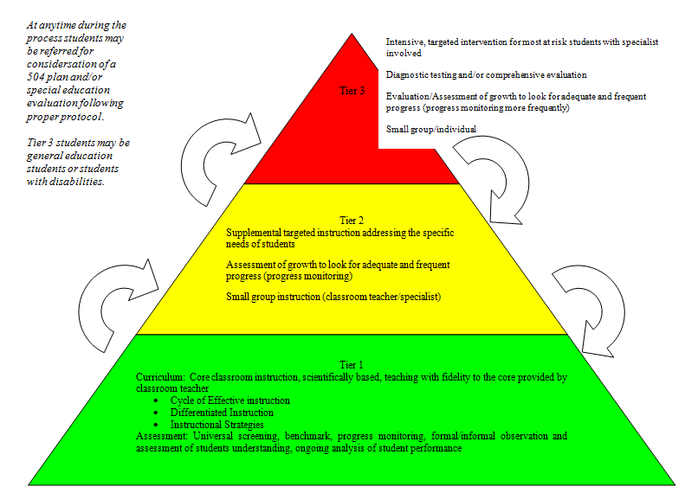(Continued)

**Amount and Nature of Student Performance Data to be Collected**

The Student Support Team will determine the amount and nature of student performance data that will be collected to assess, on an ongoing basis, student performance results and address ongoing academic needs as warranted. Such data collection will reflect the Tier Level of intervention provided to the student. Student performance data will also be used to review the District's RtI program and make modifications to the program as deemed necessary.

**Manner and Frequency for Progress Monitoring**

The Student Support Team shall monitor the progress of those students receiving intervention services beyond that provided to all students in the general education classroom. The Team shall meet with the student's teacher(s) and will determine if further adjustments need to be made to the student's current instructional program and/or a change made to the Tier Level of intervention provided. Monitoring of student progress shall be an ongoing part of the RtI program from the initial screening to completion of the RtI process as applicable. Parents may also request that the progress of their child be reviewed by the Student Support Team.

Fidelity measures (e.g., an observational checklist of designated teaching behaviors in accordance with the RtI process being implemented) will also be completed by Team members to assess whether the intervention was implemented as intended and uniformly applied. Clear benchmarks will be established for student performance and performance charts will be plotted at the completion of the instructional period/intervention process.

(Continued)

***2014*** 7212

6 of 6

Students

**SUBJECT: RESPONSE TO INTERVENTION (RTI) PROCESS (Cont'd.)**

**Staff Development**

All staff members involved in the development, provision and/or assessment of the District's RtI program, including both general education and special education instructional personnel, shall receive appropriate training necessary to implement the District's RtI program. Staff development will include the criteria for determining the levels of intervention provided to students, the types of interventions, collection of student performance data, and the manner and frequency for monitoring progress.

**Parent Notification**

Written notification shall be provided to parents when their child requires an intervention beyond that provided to all students in the general education classroom. Such written notice shall include the following information:

a) The amount and nature of student performance data that will be collected and the general education services that will be provided as part of the RtI process;

b) Strategies for increasing the child's rate of learning; and

c) The parents' right to request an evaluation for special education programs and/or services.

34 CFR Sections 300.309 and 300.311

Education Law Sections 3208, 4002, 4401, 4401-a, 4402, 4402, and 4410

8 NYCRR Sections 100.2(ii), 200.2(b)(7), 200.4(a), 200.4(j)(3)(i), and 200.4(j)(5)(i)(g)

Adoption Date